Connecting Virtual machine with a SQL server in gcp

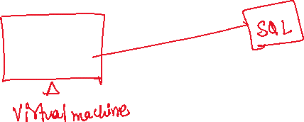

Lets first create a Virtual machine

Click on  click on compute -> instances -> create instance

Click on OS and storage

Change OS to ubuntu

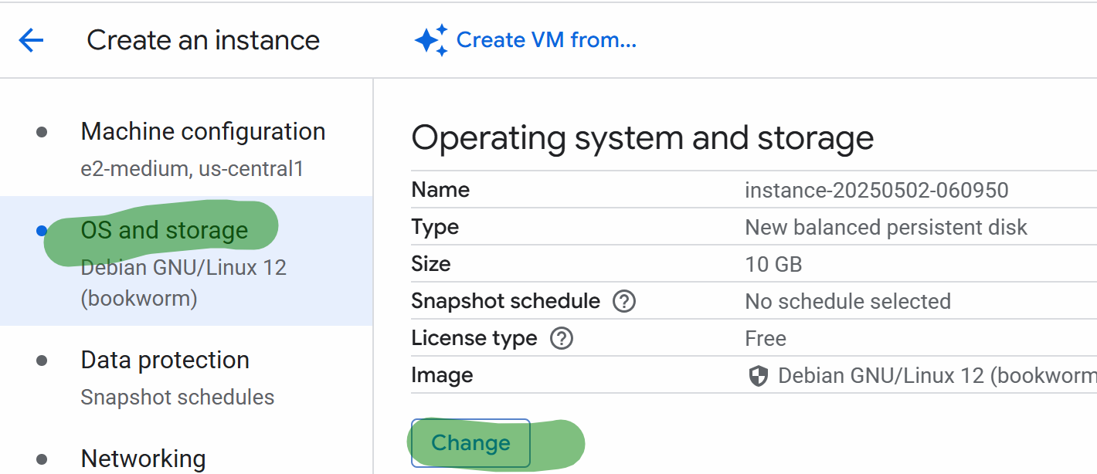

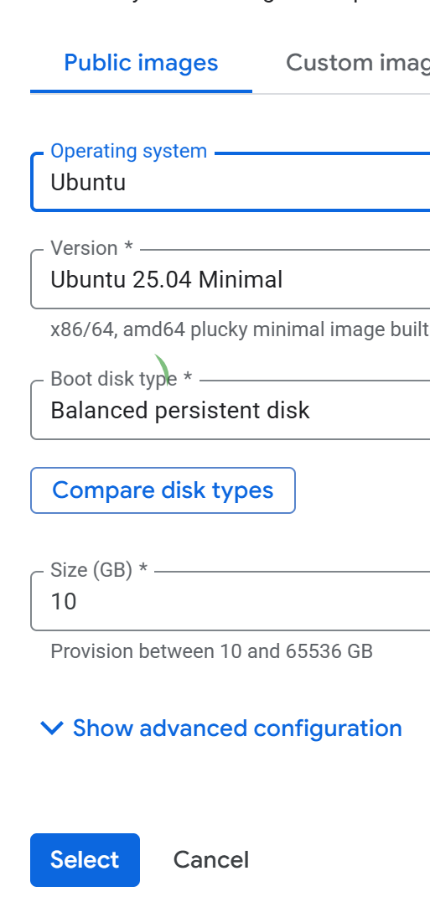



Select ubuntu

Click networking

In firewall you don’t have to select anything

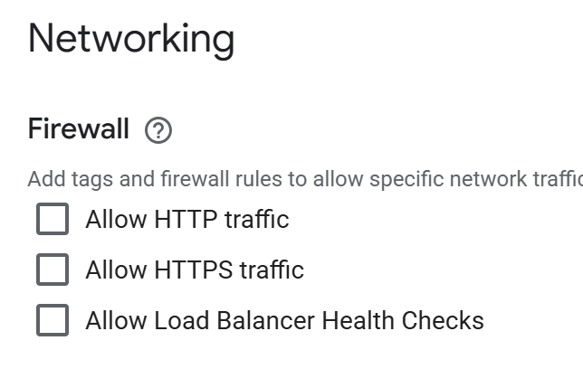No need to select any rules

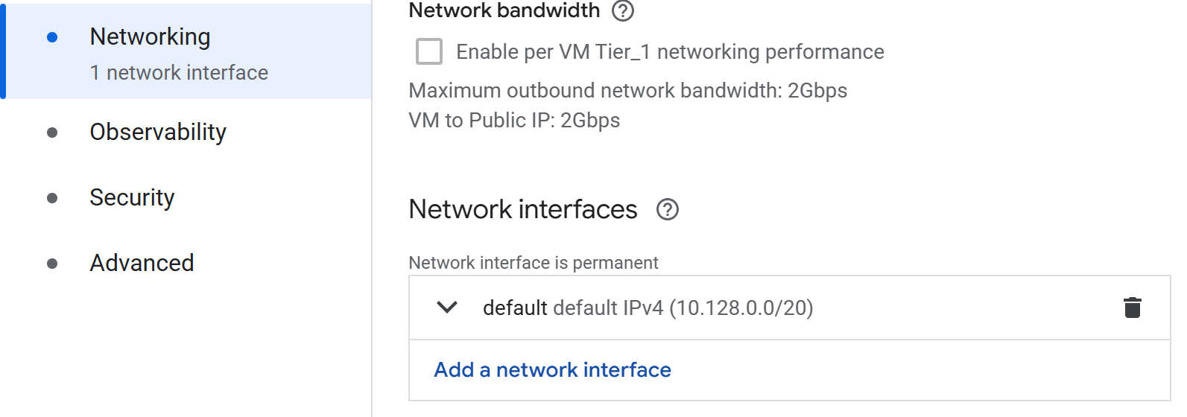



In external Ipv4 address

Reserve static ext ip address

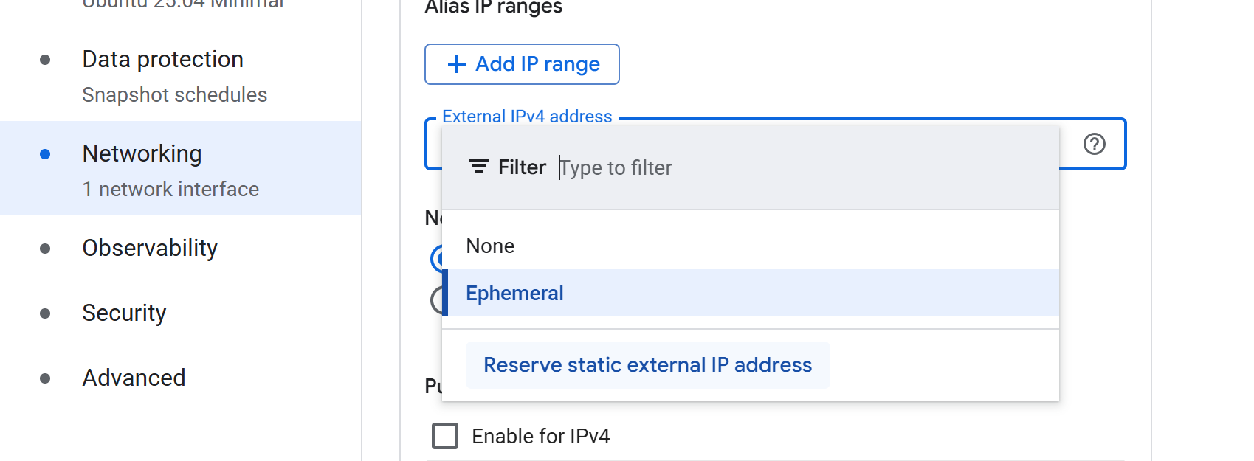



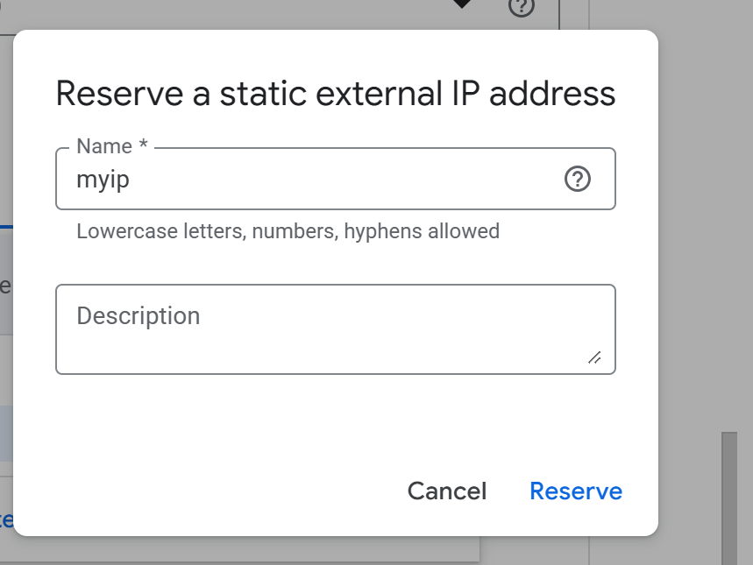



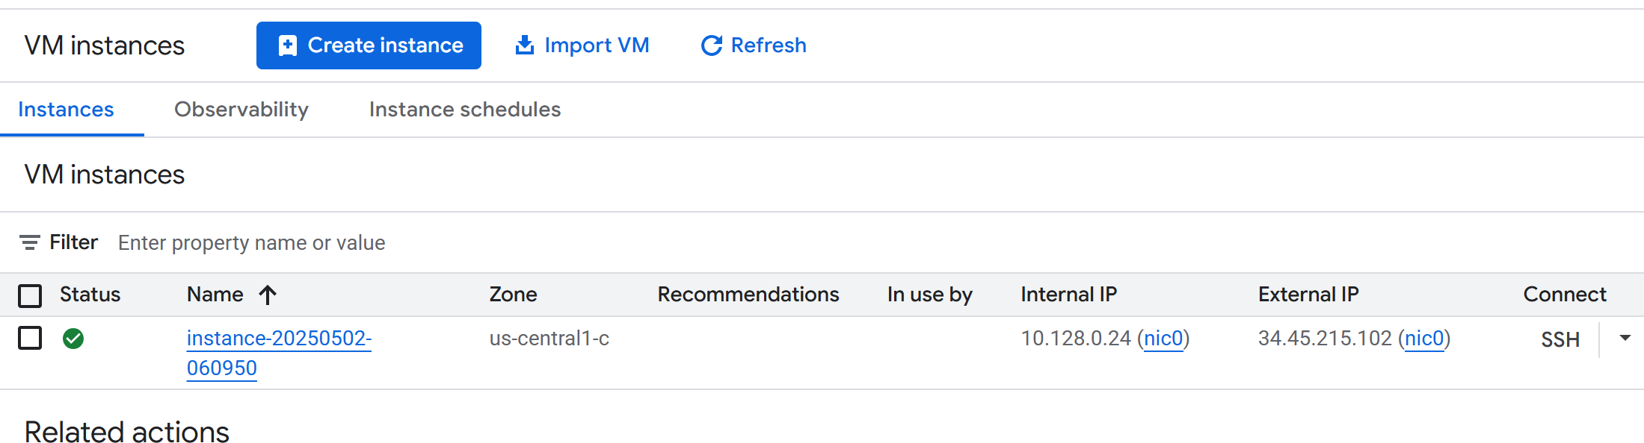



You can establish the ssh connection

## now lets create SQL

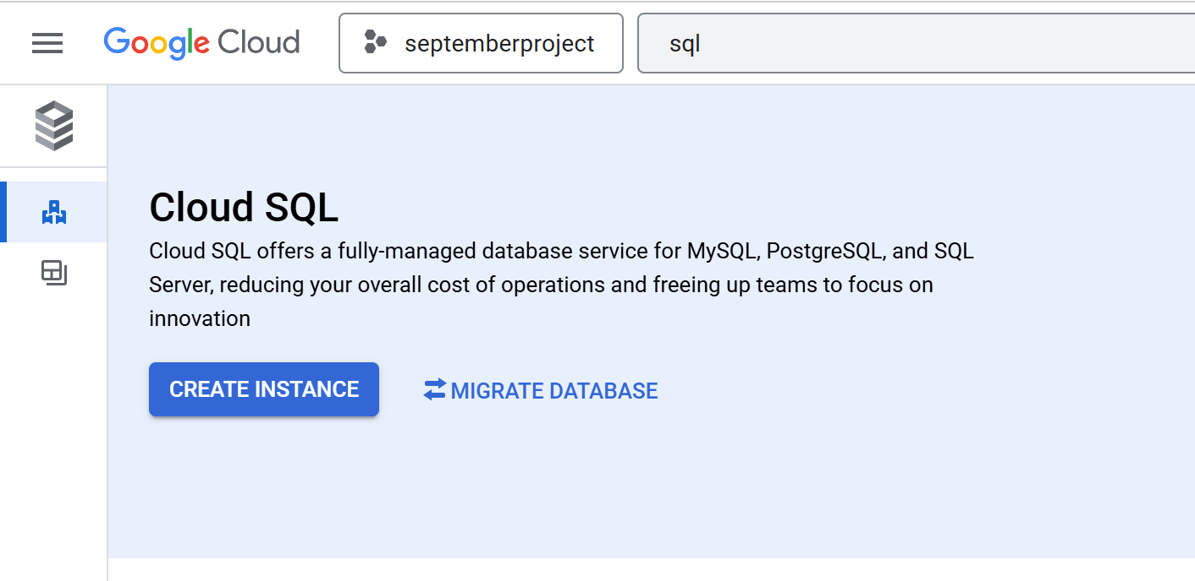  
choose MYSQL



Select enterprises

In edition present: Sandbox

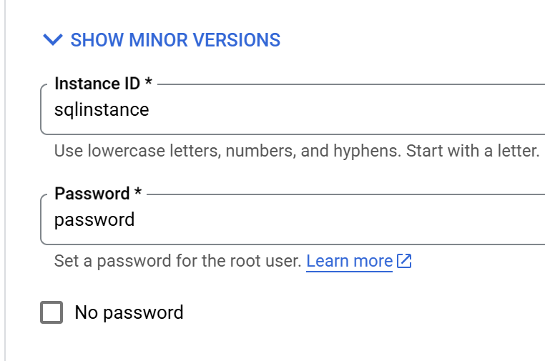



Show configuration options

Click on connections

Add a network

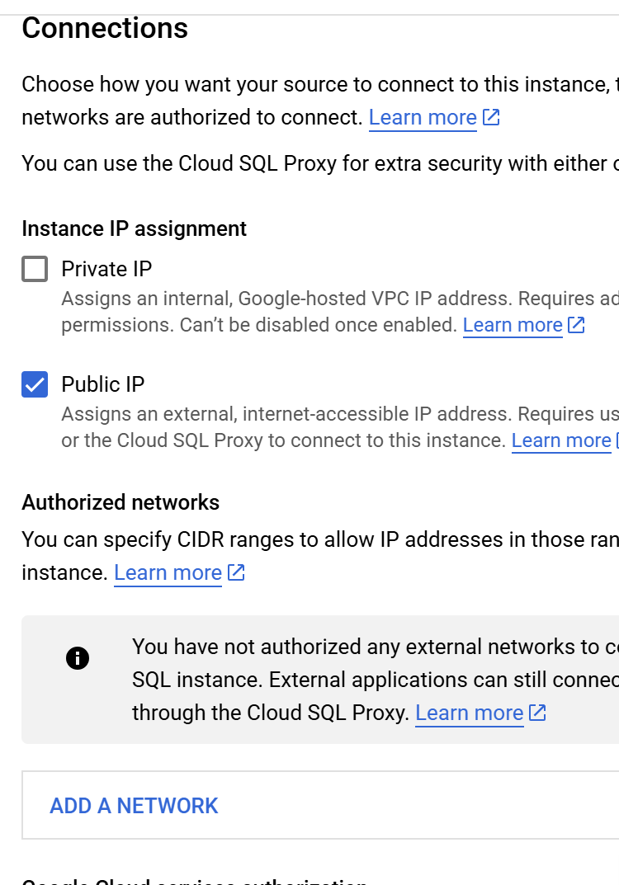

Public ip of machine (ext ip)



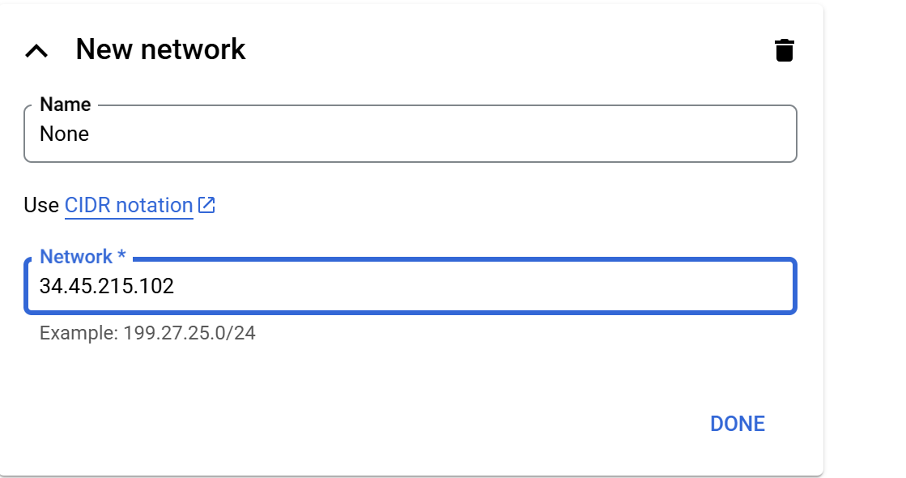



Create instance

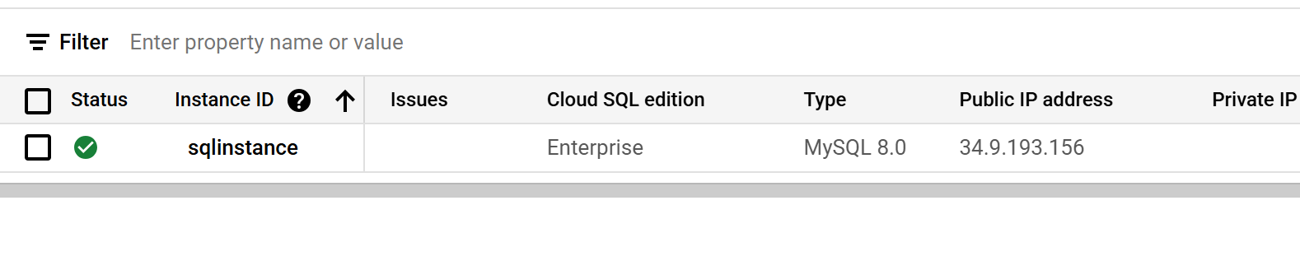  
Copy the public ip



Open CLI of the machine

Sql public ip address

sudo su

apt update



apt install mysql-client -y

mysql --host=ipaddressofsql --user=root --password  
